**EESHANYA JOSHI A3 16010122074 OOPS EXPT-2 CODE AND OUTPUT:**

**MAIN QUESTION:**

**CODE:**

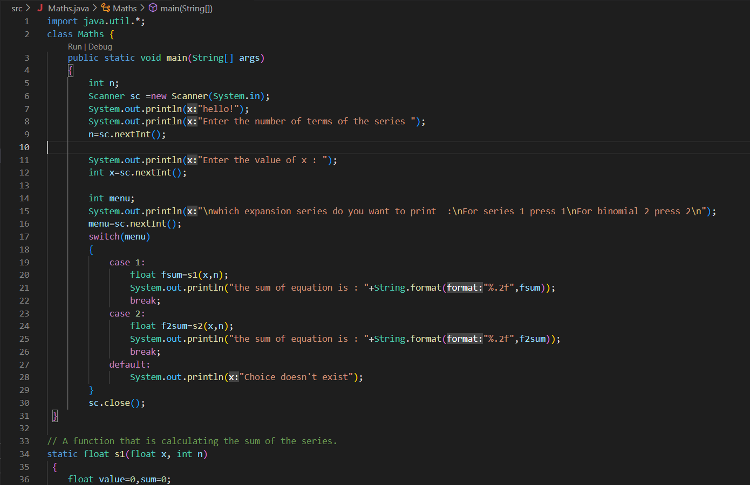

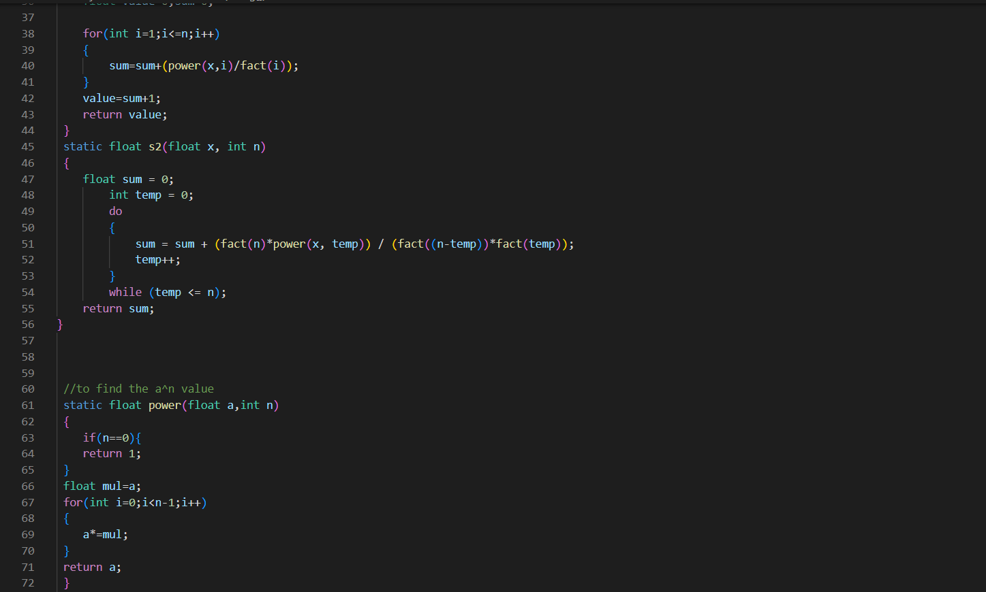

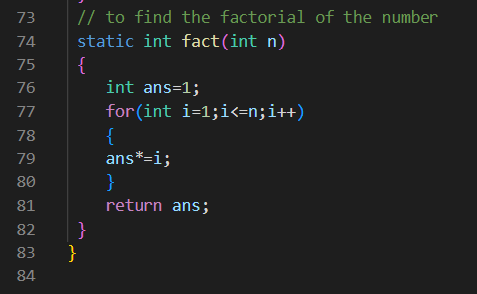

**OUTPUT:**

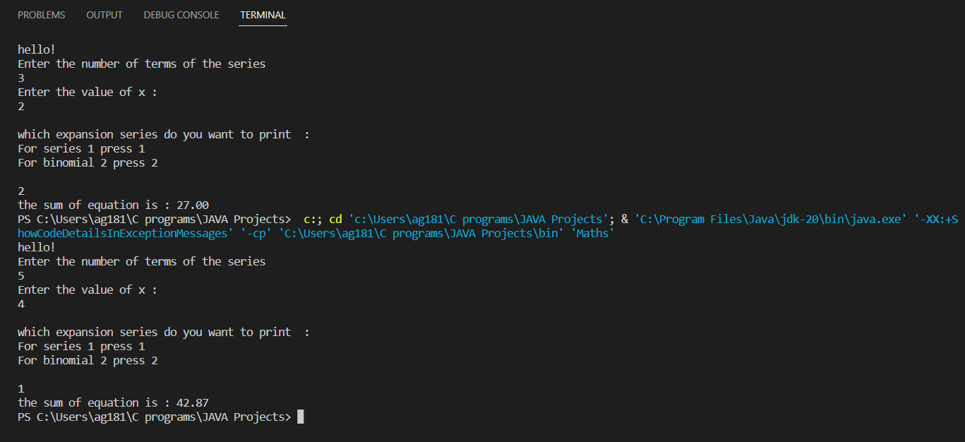

**POSTLAB QUESTION-1:** Write a program to find the largest of three numbers using the if-else construct.

**CODE:**

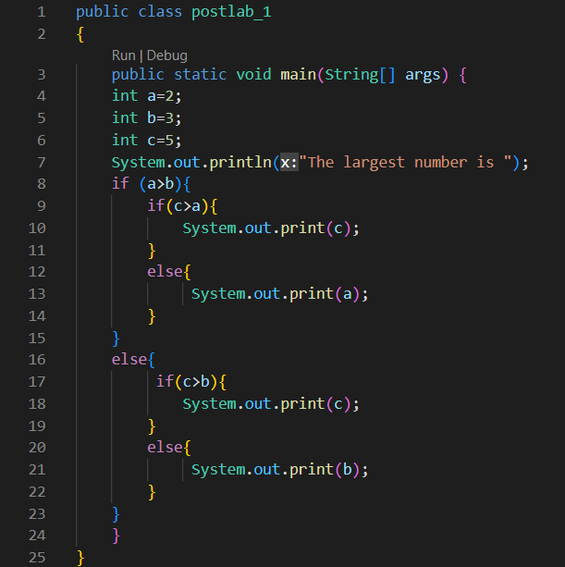

**OUTPUT:**



**POSTLAB QUESTION :2** Write a program to determine the sum of the following series for a given value of n:

1+½+⅓+....+1/n

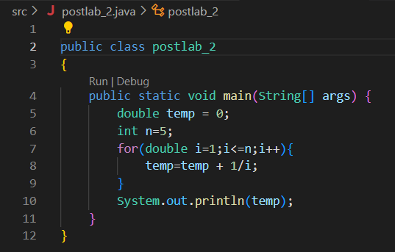

**OUTPUT:**

